**Bahria University,**

**Karachi Campus**



**LAB EXPERIMENT NO.**

_______2,3_______

**LIST OF TASKS**

|  |  |
| --- | --- |
| TASK NO | OBJECTIVE |
| 1 | Write a sketch to interface Arduino with Seven Segment Display. It should work as a decade counter. The Start / Stop of counting should be controlled through a SPDT Switch. |
| 2 | Write a sketch to interface Arduino with 16x2 Liquid Crystal Display (LCD). Write the name of your course “Embedded Systems” in the 1st Line and your Section “BEE - 8A/8B” in the 2nd Line of LCD. This Text should blink with a delay of 0.5 seconds. |
| 3 | Write a sketch to interface Arduino with 16x2 Liquid Crystal Display (LCD). First line of LCD should display your name, second line of LCD should display your registration number, and text in both line should keep moving from left to right |
|  |  |
|  |  |
|  |  |
|  |  |
|  |  |
|  |  |
|  |  |

**Submitted On:**

Code:

#define segA 2

#define segB 3

#define segC 4

#define segD 5

#define segE 6

#define segF 7

#define segG 8

#define button 10

int COUNT=0;

int ButtonState;

void setup() {

for (int i=2;i<9;i++)

{

pinMode(i,OUTPUT);

}

pinMode (10, INPUT);

}

void loop() {

ButtonState=digitalRead(button);

if(ButtonState==HIGH)

{

switch (COUNT)

{

case 0:

digitalWrite(segA, HIGH);

digitalWrite(segB, HIGH);

digitalWrite(segC, HIGH);

digitalWrite(segD, HIGH);

digitalWrite(segE, HIGH);

digitalWrite(segF, HIGH);

digitalWrite(segG, LOW);

break;

case 1:

digitalWrite(segA, LOW);

digitalWrite(segB, HIGH);

digitalWrite(segC, HIGH);

digitalWrite(segD, LOW);

digitalWrite(segE, LOW);

digitalWrite(segF, LOW);

digitalWrite(segG, LOW);

break;

case 2:

digitalWrite(segA, HIGH);

digitalWrite(segB, HIGH);

digitalWrite(segC, LOW);

digitalWrite(segD,HIGH);

digitalWrite(segE, HIGH);

digitalWrite(segF, LOW);

digitalWrite(segG, HIGH);

break;

case 3:

digitalWrite(segA, HIGH);

digitalWrite(segB, HIGH);

digitalWrite(segC, HIGH);

digitalWrite(segD, HIGH);

digitalWrite(segE, LOW);

digitalWrite(segF, LOW);

digitalWrite(segG, HIGH);

break;

case 4:

digitalWrite(segA, LOW);

digitalWrite(segB, HIGH);

digitalWrite(segC, HIGH);

digitalWrite(segD, LOW);

digitalWrite(segE, LOW);

digitalWrite(segF, HIGH);

digitalWrite(segG, HIGH);

break;

case 5:

digitalWrite(segA, HIGH);

digitalWrite(segB, LOW);

digitalWrite(segC, HIGH);

digitalWrite(segD, HIGH);

digitalWrite(segE, LOW);

digitalWrite(segF, HIGH);

digitalWrite(segG, HIGH);

break;

case 6:

digitalWrite(segA, HIGH);

digitalWrite(segB, LOW);

digitalWrite(segC, HIGH);

digitalWrite(segD, HIGH);

digitalWrite(segE, HIGH);

digitalWrite(segF, HIGH);

digitalWrite(segG, HIGH);

break;

case 7:

digitalWrite(segA, HIGH);

digitalWrite(segB, HIGH);

digitalWrite(segC, HIGH);

digitalWrite(segD, LOW);

digitalWrite(segE, LOW);

digitalWrite(segF, LOW);

digitalWrite(segG, LOW);

break;

case 8:

digitalWrite(segA, HIGH);

digitalWrite(segB, HIGH);

digitalWrite(segC, HIGH);

digitalWrite(segD, HIGH);

digitalWrite(segE, HIGH);

digitalWrite(segF, HIGH);

digitalWrite(segG, HIGH);

break;

case 9:

digitalWrite(segA, HIGH);

digitalWrite(segB, HIGH);

digitalWrite(segC, HIGH);

digitalWrite(segD, HIGH);

digitalWrite(segE, LOW);

digitalWrite(segF, HIGH);

digitalWrite(segG, HIGH);

break;

}

if (COUNT<10) {

COUNT++;

delay(1000); }

if (COUNT==10) {

COUNT=0;

delay(1000); }

}

}

Output:

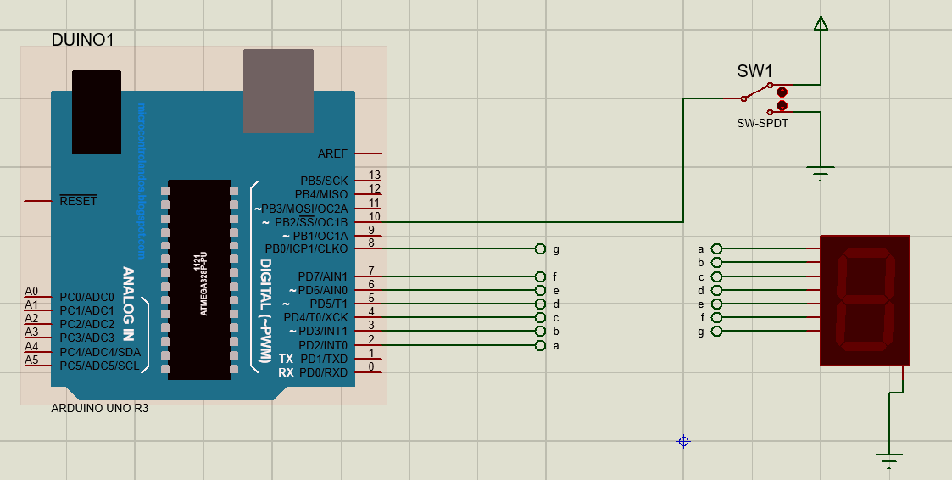

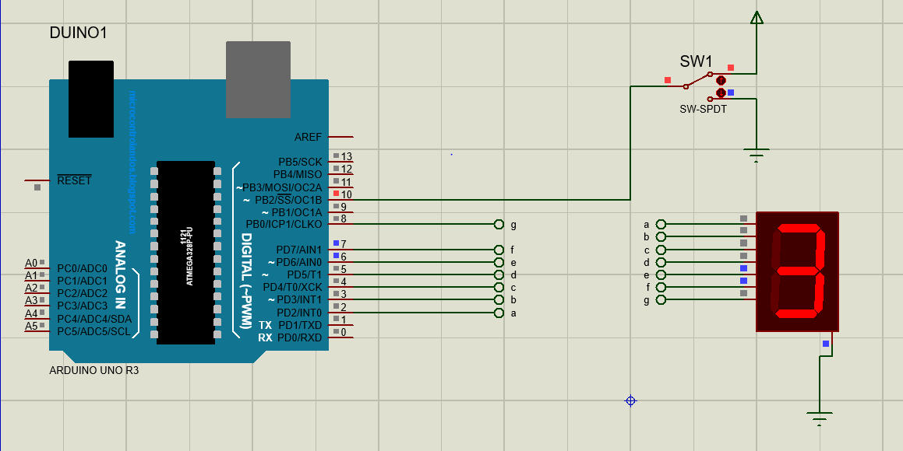

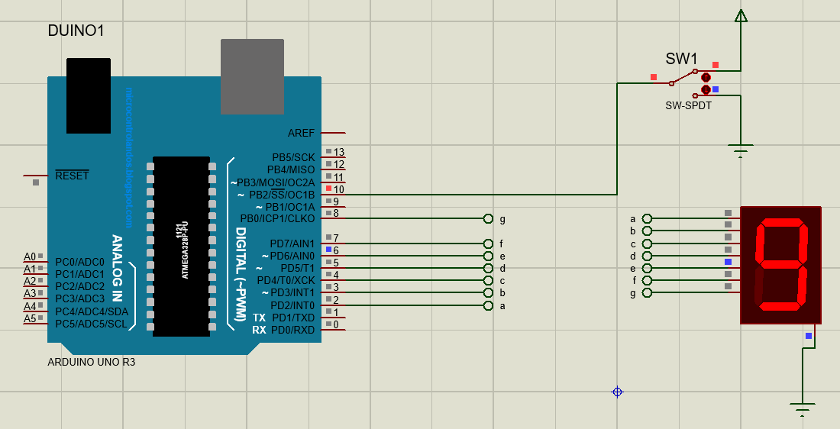

Lab #3

Code:

1:

#include <LiquidCrystal.h>

LiquidCrystal lcd(9, 8, 5, 4, 3, 2);

void setup() {

// put your setup code here, to run once:

lcd.begin(16, 2); // Setting Up the LCD No. of Rows & Columns

}

void loop() {

// put your main code here, to run repeatedly:

lcd.setCursor(0, 0);

lcd.print("Embedded Systems");

lcd.setCursor(0, 1);

lcd.print("BSE-5A");

delay(500);

lcd.clear();

delay(500);

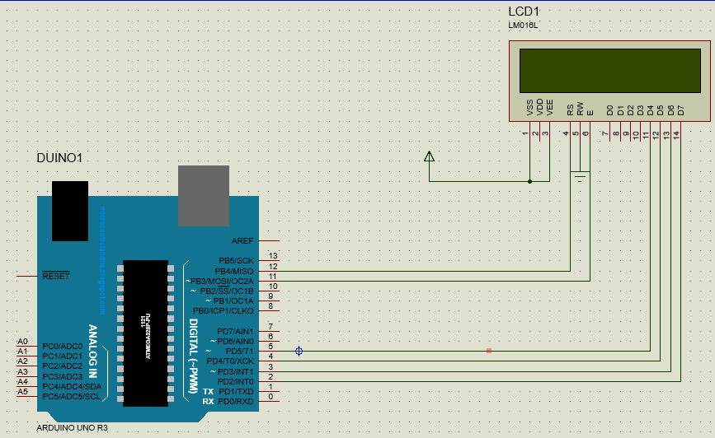

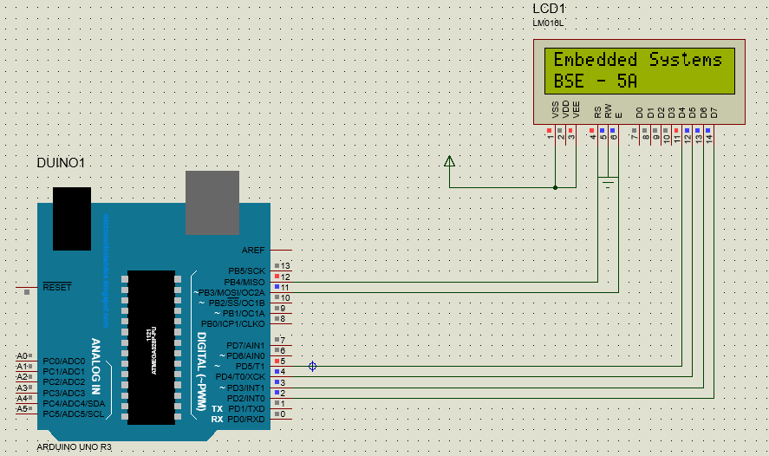

Task 2:

Maryam:

#include <LiquidCrystal.h>

LiquidCrystal lcd(12, 11, 5, 4, 3, 2);

void setup()

{

lcd.begin(16, 2); // Setting Up the LCD No. of Rows & Columns

}

void loop()

{

lcd.setCursor(0, 0);

lcd.print("Maryam Irfan");

lcd.setCursor(0, 1);

lcd.print("69980");

delay(500);

lcd.scrollDisplayLeft();

delay(500);

lcd.scrollDisplayLeft();

delay(500);

lcd.clear();

delay(500);

)

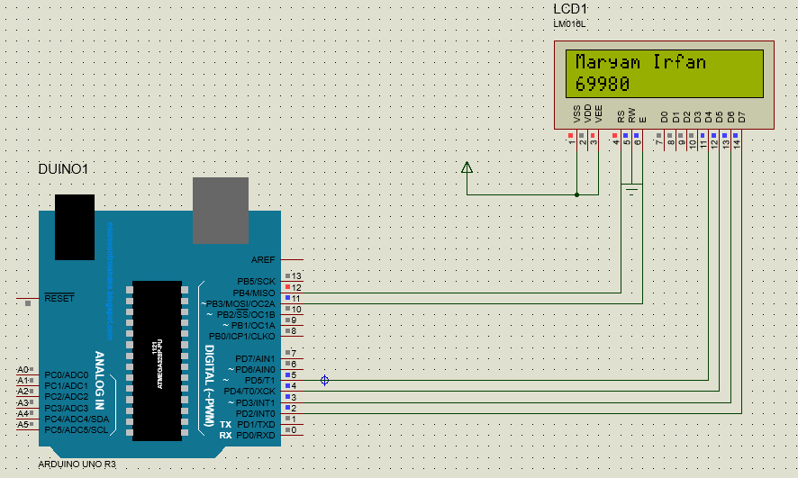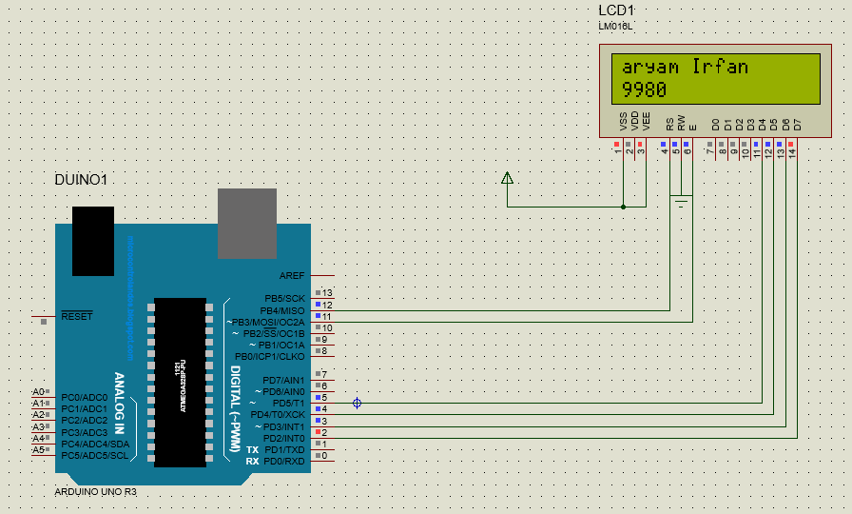

Aqib:

#include <LiquidCrystal.h>

LiquidCrystal lcd(12, 11, 5, 4, 3, 2);

void setup()

{

lcd.begin(16, 2); // Setting Up the LCD No. of Rows & Columns

}

void loop()

{

lcd.setCursor(0, 0);

lcd.print("Aqib Javed");

lcd.setCursor(0, 1);

lcd.print("69968");

delay(500);

lcd.scrollDisplayLeft();

delay(500);

lcd.scrollDisplayLeft();

delay(500);

lcd.clear();

delay(500);

)